The Effects of Athletic Ability on NFL Success

## Jack Burdick 1 , Dr. Said Bettayeb 2

1 Department of Computer Science, University of Houston – Clear Lake, 2700 Bay Area Blvd, Houston, TX 77058

2 Department of Computer Science, University of Houston – Clear Lake, 2700 Bay Area Blvd, Houston, TX 77058

# Abstract

The NFL Draft is an annual event where young college prospects are chosen to join one of 32 professional football teams. Each team has a limited number of selections and must find the best players available in order to help their team succeed. Teams will spend all year scouting college players, watching game film, and will ultimately take their athletic measurements to gauge their future potential. Even with all this studying, most players do not wind up playing in the NFL for more than 4 years. Using just a player’s athletic measurements, we wish to see if any trends can be observed to help predict whether a player will make an impact for their team.

## Introduction

Over 200 players are chosen to play professional football each year. Most of these players won’t contribute to their teams in any meaningful way, regardless of the order they’re chosen. This makes it incredibly important to be able to discern which players are worth picking, and which should be avoided. It can be tough to decide what counts as a contribution to a team though, so for the sake of our study, we will be testing how someone’s athletic ability effects their chances of making a “Pro Bowl” in their career.

In order to study this correlation, we’re going to be using the Spyder IDE to write Python code. The main goal will be to find the likelihood of drafting a pro-bowler, decide whether there are any trends that determine whether a player will be successful, and to examine what athletic measurements lead to more success. Due to positional differences, we will only be looking at running backs and receivers drafted from 2000 – 2010, as their success is largely dependent on their own skills.

## Background

Every year, fans vote on who they believe are the best players at their respective positions. These players go on to attend an event called the “Pro Bowl.” Having a pro bowl caliber player on a team can make a massive difference in a team’s future success, and the best teams typically have more than one pro-bowler on their team at any one time.

In this study, we will be using libraries in Python such as NumPy, Pandas, and Matplotlib to examine our data. All our data will come from “*Pro-Football-Reference.com”* as they have complete lists of former players and their combine results.

## Measuring the Chance of Drafting a Pro-Bowler

To truly understand how difficult drafting a Pro-Bowl caliber player is, we measured the number of Pro-Bowls each player attended and created a pie chart.

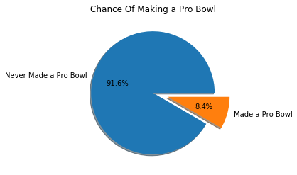

## Comparing Athletic Measurements

In order to illustrate the differences between an average player and an average pro-bowl player, we’ve constructed a series of boxplots. This was accomplished using a combination of Matplotlib and Pandas in the Spyder IDE. Listed below are 7 different boxplots showing the distribution of measurements for each group across different athletic measurements.

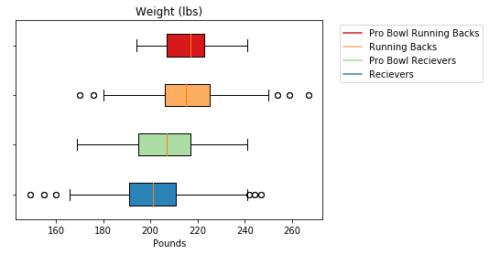

Our first measurement shows how an average player’s weight compares to a Pro-Bowler’s. As you can see, the average pro-bowl running back weighs about the same weight as an average college running back. If you look at the wide Receiver distribution though, you can see that Pro Bowl receivers tend to weigh a bit heavier than an average receiver. An interesting observation is also that the whisker for Pro Bowl Running Backs doesn’t extend very far to the left. This implies that there is a low chance of an undersized running back making a pro bowl.

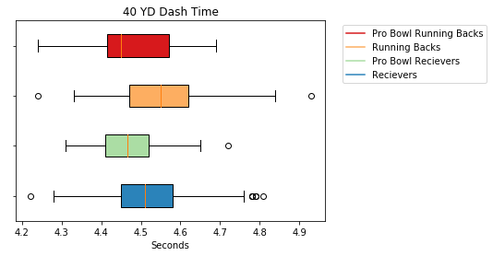

Next is the 40 YD dash time. The 40 YD dash is typically used as a measurement to test a player’s acceleration and top-end speed. A good time in the 40 typically leads to a lot of hype for a player, but doesn’t necessarily mean they will succeed in the NFL. What we see in our graph above is that Pro Bowlers typically run faster than their counterparts, but what’s interesting is that there are no Pro-Bowl receivers who ran under a 4.3. If you know anything about the NFL Draft Combine, people get very excited for times that are under 4.3, but this data shows that the fastest players don’t necessarily become great wide receivers.

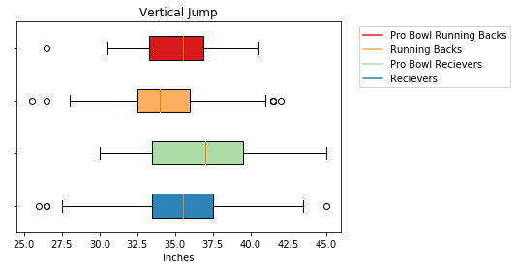

The Vertical Jump test is used to measure explosiveness and see how high a player can jump from a standstill. As you can see from the graph, the average pro bowl player jumps higher than 75% of the players at their respective positions.

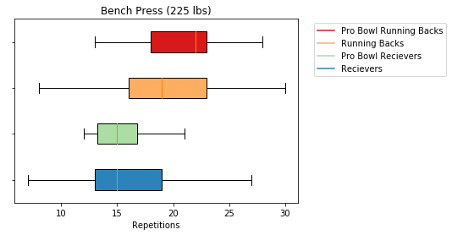

The Bench Press consists of players lifting 225 pounds as many times as they can without stopping. It is used to measure upper body strength but isn’t usually considered an important drill. Due to this, there is a very low sample size available since most people decide to skip the bench press. Going off our limited data, you can see that there isn’t much of a difference between receivers and pro bowl receivers. What is interesting is that there is a big difference between the average pro bowl running back and regular running backs. This could possibly be attributed to the fact that running backs need to sustain more hits. Receivers don’t typically take hits high on their bodies, but running backs are forced to run into defensive lineman, who are usually 6 inches taller than them, on a regular basis. It might be important for running backs to have enough upper body strength to resist being tackled high on their bodies.

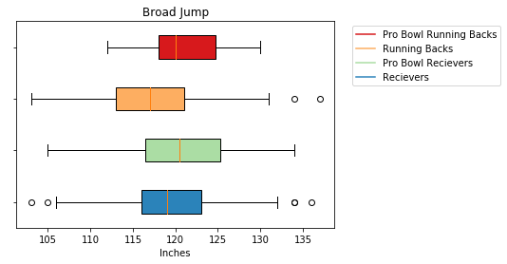

The broad jump test consists of players jumping as far forward as possible from a standing position. It is commonly used to test lower body explosiveness. While there is a small difference between pro bowl receivers and their counterparts, there is a much more pronounced difference between pro bowl running backs and their counterparts. This can possibly be attributed to the fact that explosiveness is derived from quick twitch muscles, which can also be used to make sudden movements common among running backs.

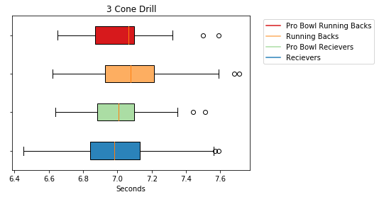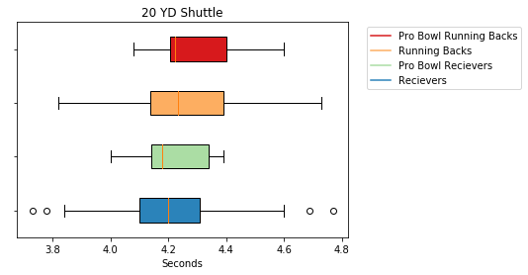

We can see that there is hardly any difference between pro-bowlers and average players when it came to the 20 YD Shuttle, or the 3 Cone Drill.

## The Effect of Athletic Ability on Sustained Success

As one last search for trends on NFL success, we used a scatter plot to compare how many times someone attended the Pro-Bowl with their athletic measurements.

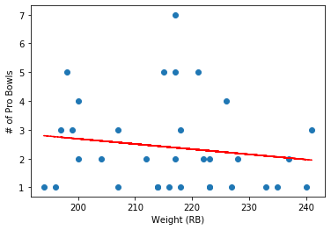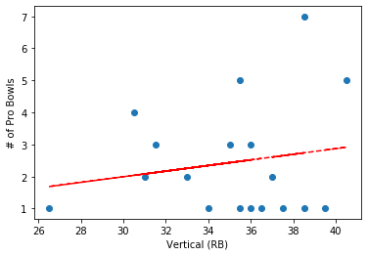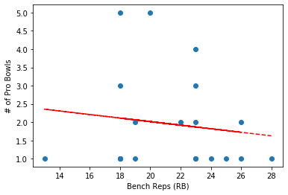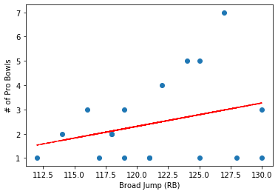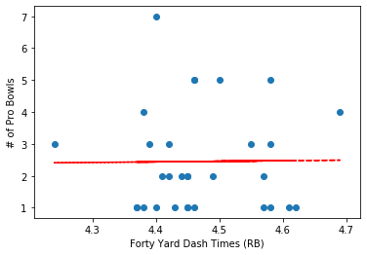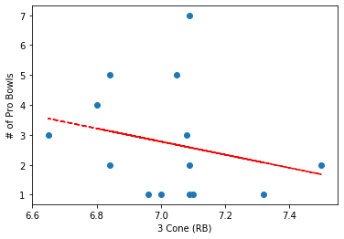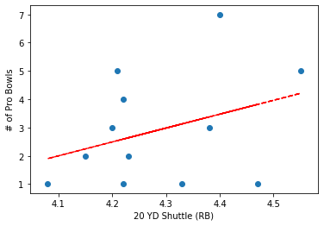Judging by this data, we can see that smaller, more athletic running backs tend to make more pro-bowlers than their heavier, stronger counterparts. This is interesting as some may think that a sturdier build would allow a better longevity and let running backs take more punishment before breaking down. Our data shows the opposite though, and that perhaps it’s more important to avoid being hit altogether than to be able to stand up to multiple hits over the course of a career. Another interesting find is that the 3 Cone Drill had the biggest impact on the amount of pro bowls a player made over their career. We would need more data to form a more concrete hypothesis about the importance of the 3 Cone Drill for running backs, but it would be an interesting idea to explore.

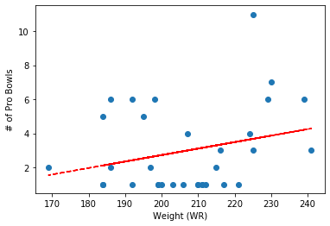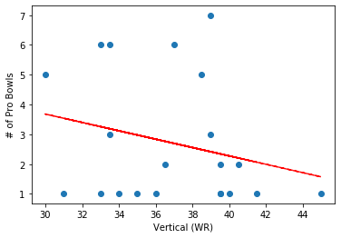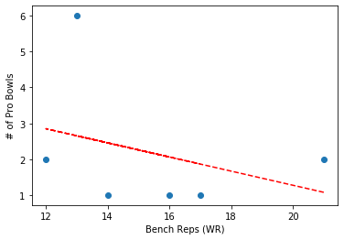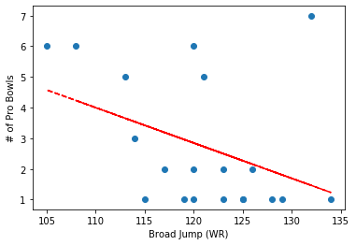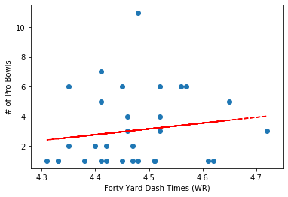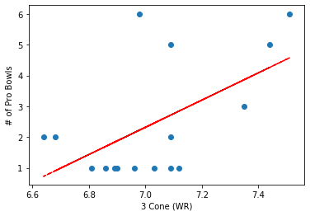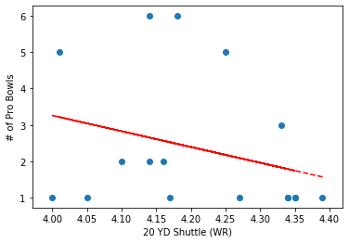

As opposed to our running back trends, our wide receiver trends seem to show that slower, heavier wide receivers can make more pro bowls over the course of their careers. This is incredibly interesting, as many receivers are expected to be the fastest players on their teams, but this shows that maybe it’s better to sacrifice athleticism for a sturdier build. Across all our metrics except one, the trend tends to favor less athleticism.

## Conclusion

By studying seven different athletic measurements for running backs and receivers we’ve been able to find a few trends that may lead to better drafts for NFL teams. When looking at running back measurements, it’s more important to find the most athletic player you can, and not worry about weight if they are at least 200 pounds. This helps them sustain hits in the NFL while also being able to avoid being hit too much. For receivers, it’s a bit trickier. For them to be successful, they need to be more athletic than the average receiver, but they also need to carry some more weight than other receivers. True superstar receivers tend to be less athletic than other pro bowl receivers, but have heavier, stronger builds in order to hold up to NFL punishments. This is a bit of a widely known fact though as outside receivers, who tend to be bigger and stronger, are valued more than slot receivers, who tend to be smaller and quicker.

When it comes to the importance of specific drills, running backs can be judged primarily on drills that test quick-twitch muscles such as the Vertical Jump and Broad Jump. Receivers tend to need a healthy balance between slow-twitch and fast-twitch muscles. This can be shown in our scatter plots as the 20 YD Shuttle time had the biggest impact on the amount of pro bowls a player made in their career.

## Works Cited